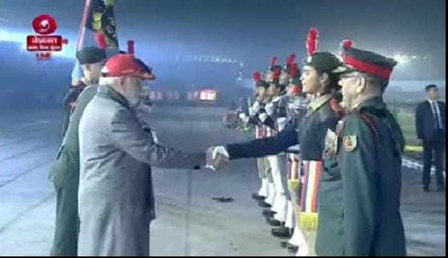

**Congratulate to Sukanya by the Prime Minister Hon. Narendra Modi.**